**FEDERAL INSTITUTE OF**

**SCIENCE AND TECHNOLOGY**

**(FISAT)TM**

**HORMIS NAGAR, MOOKKANNOOR**

**ANGAMALY-683577**



‘**FOCUS ON EXCELLENCE’**

**20MCA133 WEB PROGRAMMING LAB**

**LABORATORY RECORD**

**Name: ASWANI K R**

**Branch: MASTER OF COMPUTER APPLICATION**

**Semester: 1 Batch: 2021 A**

**Roll No: 41 Reg No:FIT21MCA-2041**

**MARCH 2022**

**FEDERAL INSTITUTE OF SCIENCE AND TECHNOLOGY**

**(FISAT)TM**

**HORMIS NAGAR, MOOKKANNOOR**

**ANGAMALY-683577**



‘**FOCUS ON EXCELLENCE’**

**CERTIFICATE**

*This is to certify that this is a Bonafide record of the Practical work done by* ***ASWANI K R(FIT21MCA-2041)*** *in the* ***20MCA133 PROGRAMMING LAB*** *Laboratorytowardsthe partial fulfilment for the award of the Master Of Computer Applications during the academic year 2021-2022.*

Signature of Staff in Charge Signature of H.O.D

Name: Name:

Date:

**Date of University practical examination ………………………**

Signature of Signature of

Internal Examiner External Examiner

**CONTENT**

|  |  |  |  |  |
| --- | --- | --- | --- | --- |
| **SI No:** | **Date :** | **Name of Experiment:** | **Page No:** | **Signature of**  **Staff –In –Charge:** |
| **1** | **01/11/2021** | Create a simple html file to demonstrate the use of different tags. | **5** |  |
| **2** | **01/11/2021** | Create your bio data by using the html tags for hyperlinks, images, table, frame and fonts . Make it attractive by using the various colour elements. The design should contain a minimum of 3 hyperlinks. | **7** |  |
| **3** | **07/11/2021** | Create an application form for MCA course in FISAT. | **9** |  |
| **4** | **21/11/2021** | Create a HTML page with different types of frames such as floating frame, navigation frame & mixed frame. | **13** |  |
| **5** | **21/11/2021** | Analyze CSS by applying the different styles using inline, external & internal style sheets in a HTML file. | **19** |  |
| **6** | **13/12/2021** | Create a HTML registration form and to validate the form using JavaScript code. | **22** |  |
| **7** | **02/01/2022** | Create a HTML page to explain the use of various predefined functions in a string and math objects in JavaScript. | **24** |  |
| **8** | **02/01/2022** | Create a HTML page to change the background color for every click of a button using JavaScript Event Handling. | **31** |  |
| **9** | **02/01/2022** | Generate the calendar using JavaScript code by getting the year and month from the user. | **34** |  |
| **10** | **10/01/2022** | Compose Electricity bill from user input based on a given tariff using PHP. | **36** |  |
| **11** | **10/01/2022** | Build a PHP code to store name of students in an array and display it using print_r function. Sort and Display the same using asort & arsort functions. | **38** |  |
| **12** | **10/01/2022** | Build a PHP code to store name of Indian Cricket players in an array and display the same in HTML table. | **39** |  |
| **13** | **01/03/2022** | Using PHP and MySQL, develop a program to accept book information viz.Accession number, title, authors, edition and publisher from a web page and store the information in a database and to search for a book with the title specified by the user and to display the search results with proper headings | **41** |  |
| **14** | **01/03/2022** | Using PHP and MySQL, develop a program to collect airline details and display all the airlines between a particular source and destination. | **47** |  |

**EXPERIMENT NO:1**

**AIM:**

Model a simple HTML file related to your native place to demonstrate the useage of different tags

**CODE:**

<html>

<head>

<title>Native place</title>

</head>

<body bgcolor="pink"><a href="biodata.htm">

<h1><center><font face="arrial" size="+3" color="blue" weight="500"><u>My Village</u></font></center></h1>

<h2><font face="arrial" size="+1" color="green" weight="400"><i><u>Asamannoor</u></i></font></h2>

<img src="village.jpeg" alt="my village" align="middle">

<p align="center">My native place   is <i><font face="arrial" size="+1" color="red" weight="300">Asamannoor.</font></i>It is a small beautiful village in the <cite> Ernakulam</cite> in <strong> Kerala.</strong>The village is rich with <code>trees,flowers,canals etc...</code><div>It is quite a large village.There are

<ul>

<li>schools</li>

<li>post office</li>

<li>hospitals etc..</li>

</ul>

The village is rich with <em><font face="arrial" size="+1" color="green" weight="300">Greenary.</font></em></div><div>The village has so many beautiful places.It does not have lots of traffic like cities,the air is pure and fresh and had so many place to play.</div>

</body>

</html>

**OUTPUT:**

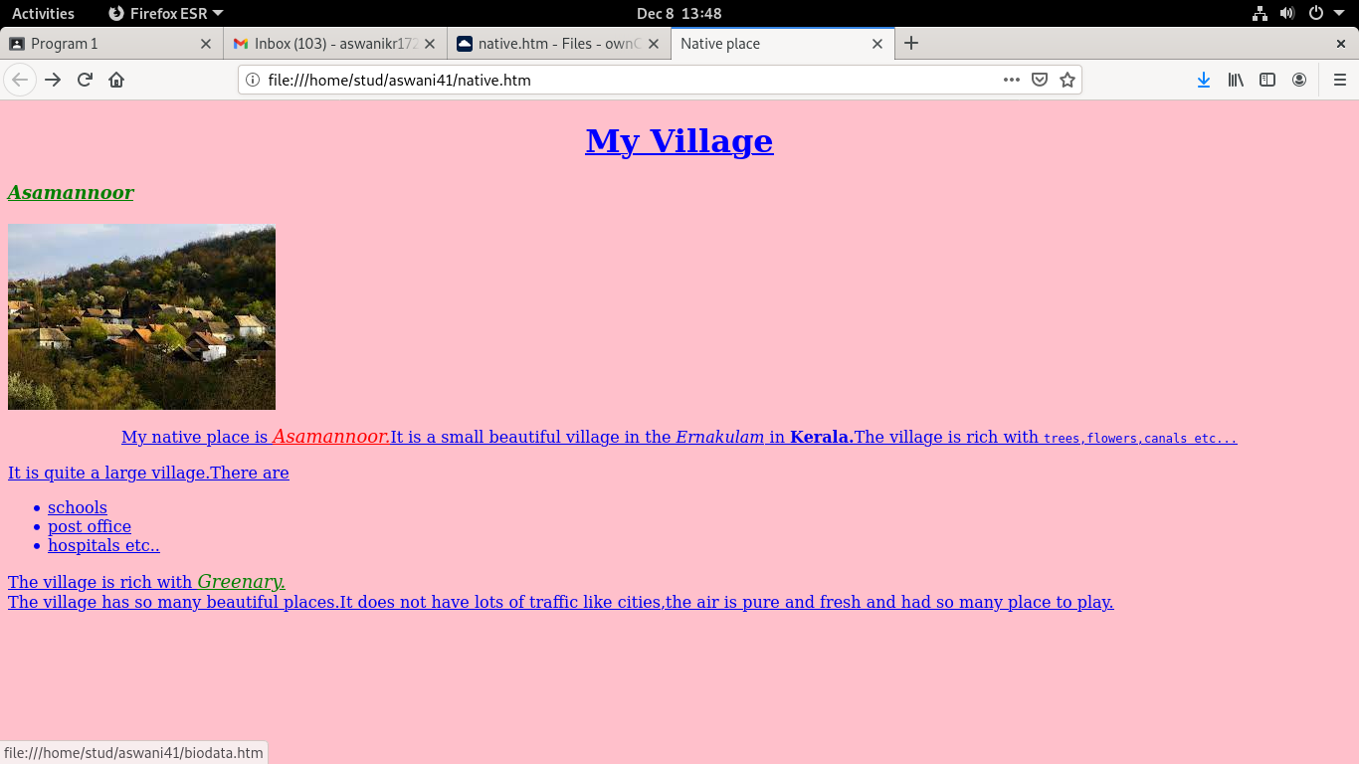

**EXPERIMENT NO:2**

**AIM**:

Create your bio data by using the html tags for hyperlinks, images, table, frame and fonts . Make it attractive by using the various colour elements. The design should contain a minimum of 3 hyperlinks.

**CODE:**

<html>

<head>

<title>Biodata Form</title>

</head>

<body>

<h1><center><i>BIODATA FORM</i></center></h1>

<table width="600" border="1" align="center">

<tr>

<th>Name</th>

<td>Aswani K R</td>

</tr>

<tr>

<th>Photo</th>

<td><img src="avatar.jpeg" alt="my picture">

<tr>

<th>Address</th>

<td>Kunnackamadathil(H) Asamannoor</td>

</tr>

<tr>

<th>Place</th>

<td><a href="native.htm">Asamannoor</td>

</tr>

<tr>

<th>Date of birth</th>

<td>17 August 2000</td>

</tr>

<tr>

<th>Gender</th>

<td>Female</td>

</tr>

<tr>

<th>E-mail</th>

<td>aswanikr172000@gmail.com</td>

</tr>

<tr>

<th>Mobile no.</th>

<td>9874562390</td>

</tr>

<tr>

<th>Qualification</th>

<td><a href="bca1.htm">BCA</td>

</tr>

</table>

</body>

</html>

**OUTPUT:**

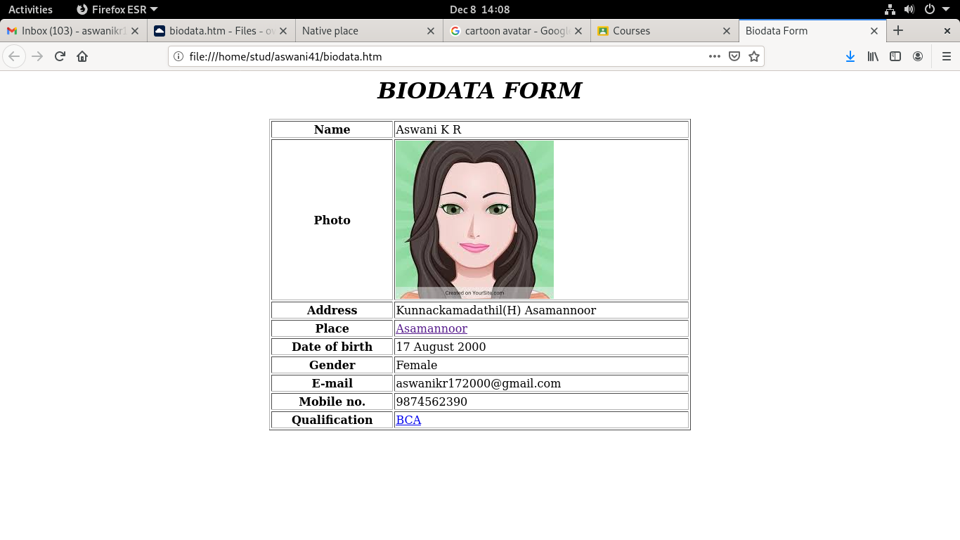

**EXPERIMENT NO: 3**

**AIM:**

Create an application form for MCA course in FISAT.

**CODE:**

<html>

<head>

<title>Form for mca</title>

</head>

<body>

<img src="index.jpeg" align="left" alt="My picture" >

<h1 align="center"><font face="arrial" size="+4" color="blue" weight="500">Fedral Institute of Science and Technology</font></h1>

<h2 align="center"><font face="arrial" size="+3" color="blue" weight="500">FISAT</font></h2>

<h3 align="center">MCA Admission</h3>

<form>

<b>Personal Details</b><br><br>

Name&nbsp;&nbsp;&nbsp;&nbsp;&nbsp&nbsp;&nbsp;&nbsp;&nbsp;&nbsp&nbsp;&nbsp;&nbsp;&nbsp;&nbsp&nbsp;&nbsp;&nbsp;&nbsp;&nbsp;&nbsp&nbsp;&nbsp<input name="name" type="text" size="50"><br><br>

Permanent Address&nbsp;&nbsp<textarea name="address" rows="5" cols="50"></textarea><br><br>

Mobile&nbsp;&nbsp;&nbsp;&nbsp&nbsp;&nbsp;&nbsp;&nbsp;&nbsp&nbsp;&nbsp;&nbsp;&nbsp;&nbsp&nbsp;&nbsp;&nbsp;&nbsp;&nbsp;&nbsp&nbsp;&nbsp<input name="mobile" type="number" size="50"><br><br>

Alternative Phn.no&nbsp;&nbsp;&nbsp;<input name="alternativenumber" type="number" size="50"><br><br>

Address for communication<br>

Same as permanent address<input type="checkbox" name="address" value="address"><br><br>

Email&nbsp;&nbsp;&nbsp;&nbsp;&nbsp&nbsp;&nbsp;&nbsp;&nbsp;&nbsp&nbsp;&nbsp;&nbsp;&nbsp;&nbsp&nbsp;&nbsp;&nbsp;&nbsp;&nbsp;&nbsp&nbsp;&nbsp<input name="email" type="email" size="50"><br><br>

DateofBirth&nbsp;&nbsp;&nbsp;&nbsp;&nbsp;&nbsp;&nbsp;&nbsp&nbsp;&nbsp;&nbsp;&nbsp&nbsp;<input type="date"><br><br>

Gender&nbsp;&nbsp;&nbsp;&nbsp;&nbsp&nbsp;&nbsp;&nbsp;&nbsp;&nbsp&nbsp;&nbsp;&nbsp;&nbsp;&nbsp&nbsp;&nbsp;&nbsp;&nbsp;&nbsp;&nbsp&nbsp;&nbsp

Male<input type="radio" name="gender" value="gender">

Female<input type="radio" name="gender" value="gender"><br><br>

Nationality&nbsp;&nbsp;&nbsp;&nbsp;&nbsp&nbsp;&nbsp;&nbsp;&nbsp;&nbsp&nbsp;&nbsp;&nbsp;&nbsp;&nbsp&nbsp;&nbsp;<input name="nation"  type="text" size="50"><br><br>

Religion&nbsp;&nbsp;&nbsp;&nbsp;&nbsp&nbsp;&nbsp;&nbsp;&nbsp;&nbsp&nbsp;&nbsp;&nbsp;&nbsp;&nbsp&nbsp;&nbsp;&nbsp&nbsp;&nbsp;&nbsp;

<select name="religion">

<option>Hindu

<option>Christian

<option>Muslim

<option>Others</select>&nbsp;&nbsp

Community<input name="community" type="text" size="20">&nbsp

Category

<select name="category">

<option>General

<option>SC

<option>ST

<option>OBC

<option>OEC

<option>Others</select><br><br>

Fathers Details<br>

Father's Name&nbsp&nbsp;&nbsp;&nbsp;&nbsp;&nbsp&nbsp;&nbsp;&nbsp;&nbsp;&nbsp&nbsp;<input name="details" type="text" size="50"><br><br>

Occupation&nbsp;&nbsp;&nbsp;&nbsp;&nbsp&nbsp;&nbsp;&nbsp;&nbsp;&nbsp&nbsp;&nbsp;&nbsp&nbsp;&nbsp;&nbsp&nbsp<input name="occupation" type="text" size="50"><br><br>

Phone Number&nbsp;&nbsp&nbsp;&nbsp;&nbsp;&nbsp;&nbsp&nbsp;&nbsp;&nbsp&nbsp;&nbsp;<input name="number" type="number" size="50"><br><br>

Mothers Details<br>

Mothers name&nbsp&nbsp;&nbsp;&nbsp&nbsp;&nbsp;&nbsp&nbsp;&nbsp;&nbsp;&nbsp;&nbsp&nbsp;<input name="details" type="text" size="50"><br><br>

Occupation&nbsp;&nbsp;&nbsp;&nbsp;&nbsp&nbsp;&nbsp;&nbsp&nbsp;&nbsp;&nbsp;&nbsp;&nbsp&nbsp;&nbsp;&nbsp&nbsp<input name="occupation" type="text" size="50"><br><br>

Phone Number&nbsp;&nbsp&nbsp;&nbsp;&nbsp;&nbsp;&nbsp&nbsp;&nbsp;&nbsp;&nbsp&nbsp;<input name="number" type="number" size="50"><br><br>

Annual Income&nbsp;&nbsp&nbsp;&nbsp;&nbsp&nbsp;&nbsp;&nbsp;&nbsp;&nbsp&nbsp;<input name="income" type="number" size="50"><br><br>

<b>Academic Qualification</b><br><br>

Entrance Rank<br>(if available)&nbsp&nbsp;&nbsp;&nbsp&nbsp;&nbsp;&nbsp;&nbsp;&nbsp&nbsp;&nbsp&nbsp;&nbsp;&nbsp<input name="rank" type="text" size="50"><br><br>

Tenth % &nbsp&nbsp;&nbsp&nbsp;&nbsp;&nbsp&nbsp;&nbsp;&nbsp;&nbsp&nbsp&nbsp;;&nbsp;&nbsp;&nbsp&nbsp;&nbsp;&nbsp;&nbsp&nbsp;<input name="percentage" type="number" size="50"><br><br>

Tweleth % &nbsp&nbsp;&nbsp&nbsp;&nbsp;&nbsp;&nbsp&nbsp&nbsp;;&nbsp;&nbsp;&nbsp&nbsp;&nbsp;&nbsp;&nbsp<input name="percentage" type="number" size="50"><br><br>

Whether candidate has studied mathematics at +2/degree %<br>

Yes<input type="radio" name="yes" value="yes">

No<input type="radio" name="no" value="no"><br><br>

Graduation Course taken/completed<br>

Bsc<input type="radio" name="bsc" value="bsc">

BCA<input type="radio" name="bca" value="bca">

Bcom<input type="radio" name="bcom" value="bcom">

Others<input type="radio" name="other" value="other"><br><br>

Degree Percentage&nbsp;&nbsp&nbsp;&nbsp;&nbsp;&nbsp;&nbsp&nbsp;<input name="percentage" type="number" size="50"><br><br>

Semester upto<br> result availabe&nbsp;&nbsp&nbsp;&nbsp;&nbsp&nbsp;&nbsp;&nbsp&nbsp;&nbsp;&nbsp;&nbsp;&nbsp&nbsp;<input name="result" type="text" size="50"><br><br>

Remarks&nbsp;&nbsp&nbsp;&nbsp;&nbsp;&nbsp;&nbsp&nbsp;&nbsp;&nbsp&nbsp;&nbsp;&nbsp&nbsp;&nbsp;&nbsp;&nbsp;&nbsp&nbsp;&nbsp;&nbsp&nbsp;<input name="remark" type="text" size="50"><br><br><br>

<input type="submit" name="submit" value="submit">

<input type="reset" name="clear" value="clear"

</form>

</body>

</html>

**OUTPUT:**

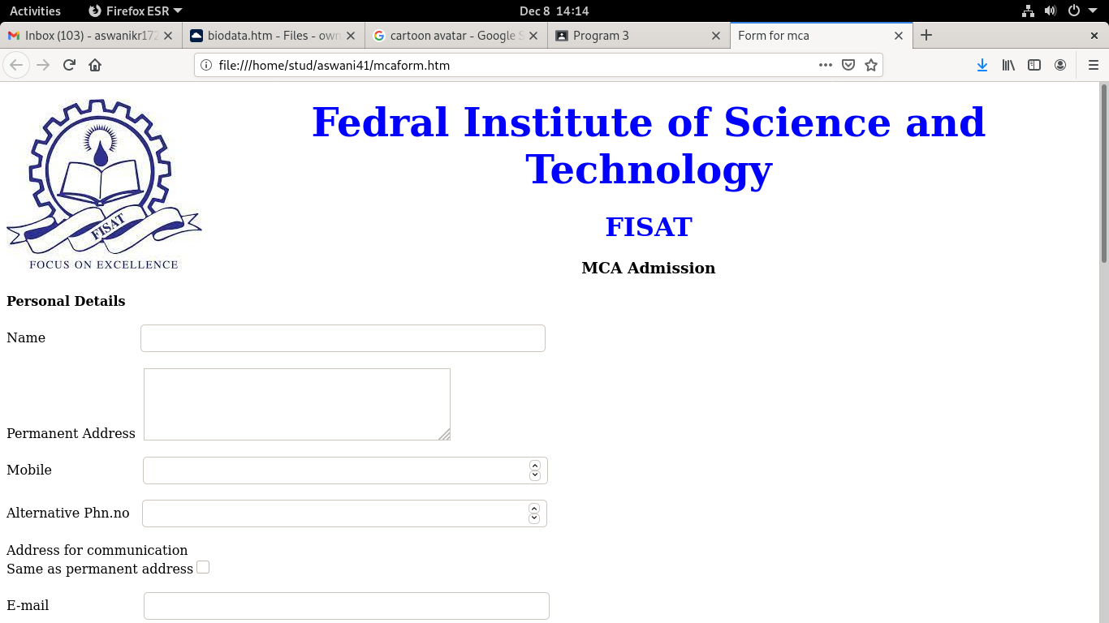

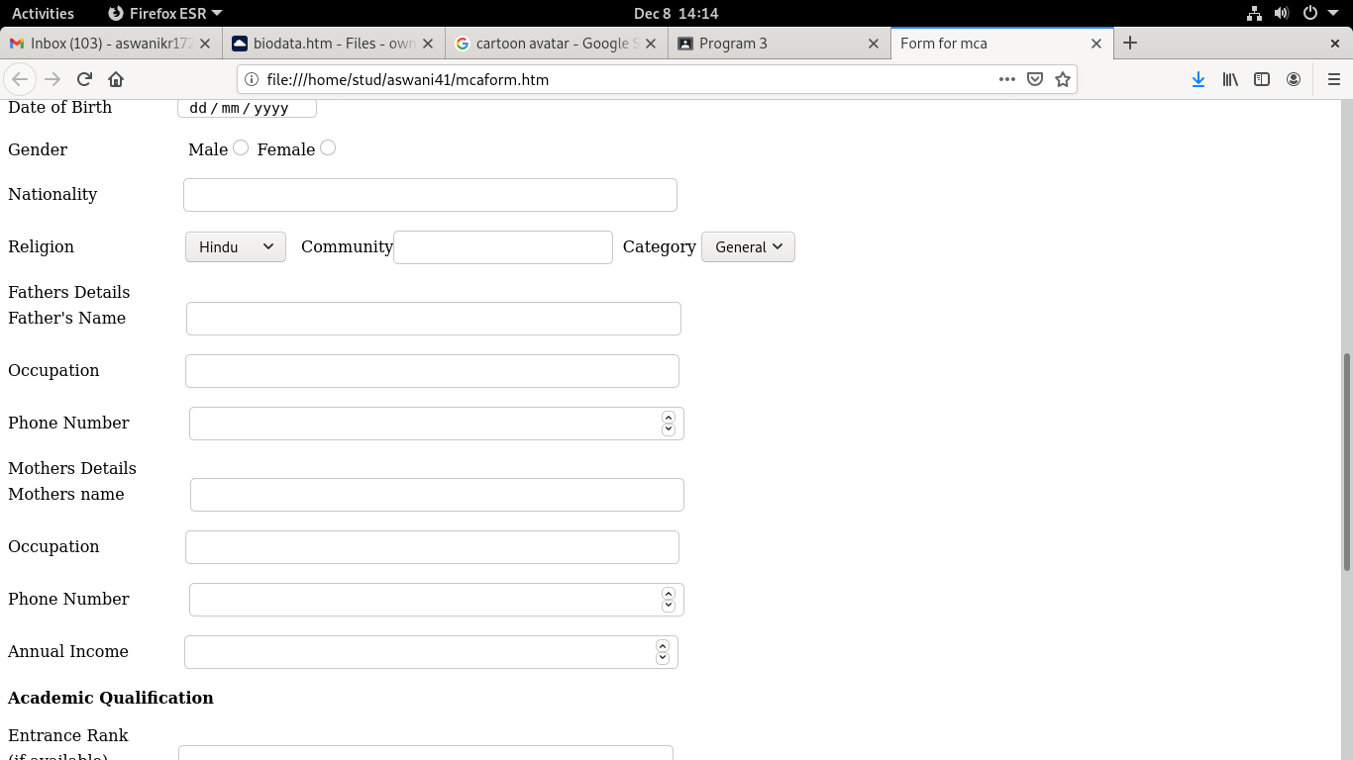

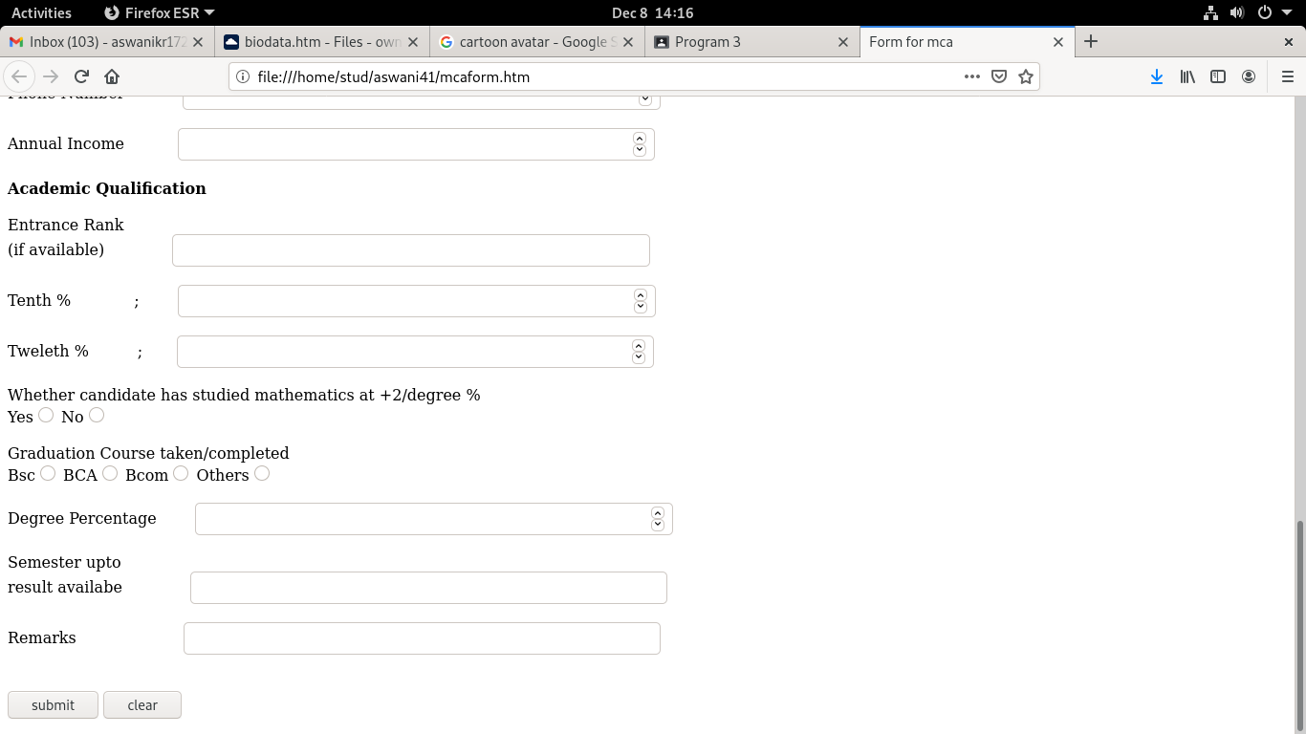

**EXPERIMENT NO: 4**

**AIM:**

Create a HTML page with different types of frames such as floating frame,navigation frame & mixed frame.

**CODE:**

course.htm

<html>

<head>

<title>course</title>

</head>

<body>

<h4>Department of computer science and engineering</h4>

<table border="2" width="1000" height="400">

<tr>

<th>Programe </th>

<th>duration</th>

</tr>

<tr>

<td> B.Tech in Computer Science & Engineering (CSE)  </td>

<td>4 yrs</td>

</tr>

<tr>

<td> B.Tech in Computer Science & Design </td>

<td>4 yrs</td>

</tr>

<tr>

<td> M.Tech in Computer Science & Information Systems (CSIS) </td>

<td>2 yrs</td>

</tr>

</table>

<h4>Department of electronics and communication</h4>

<table border="2" width="1000" height="400">

<tr>

<th>Programe </th>

<th>duration</th>

</tr>

<tr>

<td>  B.Tech in Electronics & Communication Engineering (ECE)   </td>

<td>4 yrs</td>

</tr>

<tr>

<td>  M.Tech in VLSI & Embedded Systems </td>

<td>2 yrs</td>

</tr>

<tr>

<td>  M.Tech in Automotive Electronics </td>

<td>2 yrs</td>

</tr>

</body>

</html>

frame.htm

<html>

<head>

<title>Frames</title>

<head>

<frameset rows="30%,*">

<frame name="top" src="profile.html">

<frameset cols="140,*">

<frame name="navF" src="navigation.html">

<frame name="mainF" src="intro.html">

</frameset>

</frameset>

<body>

infrastructure.htm

<html>

<head>

<title></title>

<head>

<h1>infrastructure</h2>

<body>

<p>Infrastructure

The infrastructure facilities of FISAT are tailored to support holistic education with emphasis on sustainability. The master plan of FISAT envisages a three storeyed main building consisting of a central block with college office, central library, main computer centre, office of the principal, conference hall, spacious seminar halls, etc housed in it and the major building complexes on the side accommodates classrooms, drawing halls, tutorial halls, departmental offices, libraries, and computer centres. The central block of the institution is constructed in an eco-friendly manner without obstructing the flow of a natural stream.

<p>The classrooms are well ordered and spacious with latest audio-visual aids and wifi facility. FISAT Library is the soul of the institution and it acquires, processes, preserves and disseminates information to the user community with the motto of focus on excellence. It has an extensive collection of books, reference materials for satisfying the academic and research needs of the students and faculty. FISAT Library and Information Centre consists of a reference section, circulation section and periodical section. The library has automated all its activities to provide an effective and wide range of academic resources such as books, journals, online databases.

</html>

intro.htm

<html>

<head><title>FISAT</title></head>

<body align="center">

<center>

<h1> Federal Institute Of Science Technology</h1>

<img src="fisatlogo.png" width="500" height="400">

</center>

</body>

</html>

library.htm

<html>

<head>

<title></title>

<head>

<h1>library</h2>

<body>

<p>The College

<p>Motto:  Read Mould Motivate: Read to Mould yourself and Motivate others

<p>FISAT Library offers the students access to an invaluable collection of books, journals, videos, and CD\DVD’s and is continuously furnished with new and relevant reference materials.  The library is fully computerized which makes the accessibility easier for the students.  It functions throughout the year from 8 am to 7 pm on all days except Sundays and other holidays. This gives the students an excellent opportunity to improve their understanding and knowledge. The Institution library is equipped with over 19000 titles, 80551 Volumes, 2600 CD/DVDs, 289 journals and periodicals and 12 newspapers.  It has access to online databases such as DELNET, EBSCO-Business Source Elite, IEEE, ASME, ASCE, Elsevier Science Direct, EBSCO E books etc.

The institution has a fully automated library with modern software and an OPAC system. It provides excellent learning resources, catering to the ever-growing intellectual requirements of the students, faculty, and researchers. It is also equipped with a repository of learning materials of NPTEL. The association with DELNET enables access to various journals from 7284 libraries in South Asia. Besides the Main Library, there are Nine separate department libraries.

<p>Book Purchase Policy

<p>Book purchase in FISAT library is a continuous process, on the basis of recommendations from faculty members and approval from the purchase committee. Books are purchased according to priority and available budget. Publishers and Vendors provide electronic lists of titles available for purchase, and printed catalogues. These are forwarded to the Department Heads. The list of books requested by the faculty members and student requests approved by the respective Department Heads are considered for purchase. Besides catalogues, text book requirements by students are also considered for book purchase. Library also conducts book exhibitions at regular intervals to enable book selection by faculty members and students.

<p>Maintenance and Stock Verification

<p>FISAT library is fully automated using KOHA. All books are marked, classified and advantageously placed on the racks. The positions of the books are updated with the Dewey Decimal Classification (DDC) for easy retrieval. As a proactive intervention, all books are periodically inspected to find possible damages and binding is carried out if necessary. The annual stock verification is done as a part of regular procedure. Books are issued using barcode system. Lost books are replaced by the borrower. The library is overall monitored by Chief Librarian & Library Committee.

 </body>

</html>

navigation.htm

<html><head><title>Navigation Bar</title></head>

<body><center>

<a href="intro.html" target="mainF">HOME</a><br><br>

<a href="course.html" target="mainF">COURSE</a><br><br>

<a href="profile.html" target="mainF">PROFILE</a><br><br>

</center></body>

</html>

profile.htm

<html>

<head>

<title></title>

<head>

<h1>Pofile</h2>

<body>

<p>The College

<p>Federal Institute of Science And Technology (FISAT) is a private self financing Engineering College, established and run by the Federal Bank Officers` Association Educational Society (FBOAES). The FBOAES is an initiative of the Federal Bank Officers` Association (FBOA), the sole representative body of the entire officers of the Federal Bank.

Federal Institute of Science And Technology (FISAT) has a unique position in the Professional Education Sector in South India. With the motto "Focus on Excellence", FISAT has been designed and developed to become a `Centre of Excellence` in professional education.  Established in the year 2002, the college has carved a niche for itself in education world, eloquently demonstrated by the flying colors attained by its students in academics, placements as well as extra curricular and co curricular activities. FISAT has embarked on an ambitious plan to enhance the quality and value of education and develop high quality individuals. The institution is accredited by NAAC with 'A' Grade. Five B.Tech branches are accredited by NBA. The institution also received the coveted ISO 9001:2015 certification.

<p>FISAT is set up at Mookannoor, near Angamaly in Ernakulam District, Kerala, the birth place of the founder of The Federal Bank Ltd, Late K P Hormis. To honour the revered memory of the great visionary, the campus of FISAT is christened `Hormis Nagar`.

 <iframe src="infrastructure.html" width="800" height="400"algin="center"></iframe><br>

<p>FISAT is affiliated to Kerala Technological University (KTU), Mahatma Gandhi University, Kottayam, Kerala and approved by All India Council for Technical Education (AICTE),  New Delhi.

<p>FISAT conducts six B.Tech courses in Engineering, MBA programme (with specialization in Finance, Marketing, Human Resource Management, Information System, Production & Operations Management and International Business), MCA programme and six M.Tech courses.

</html

**OUTPUT:**

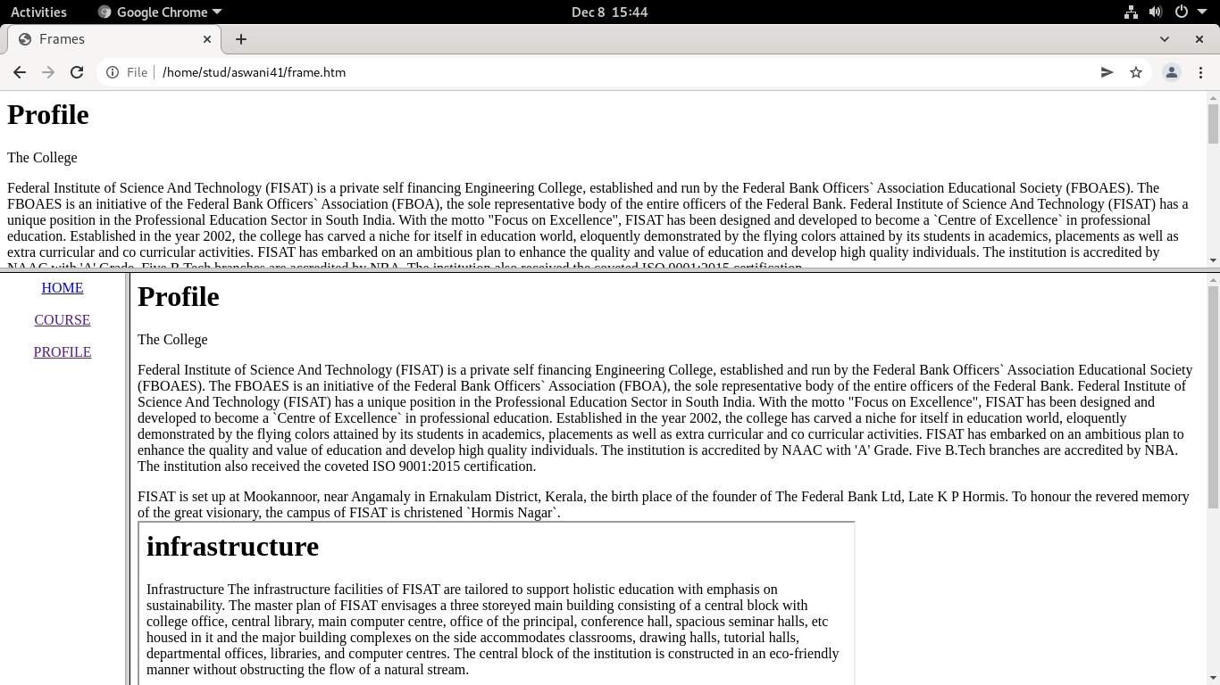

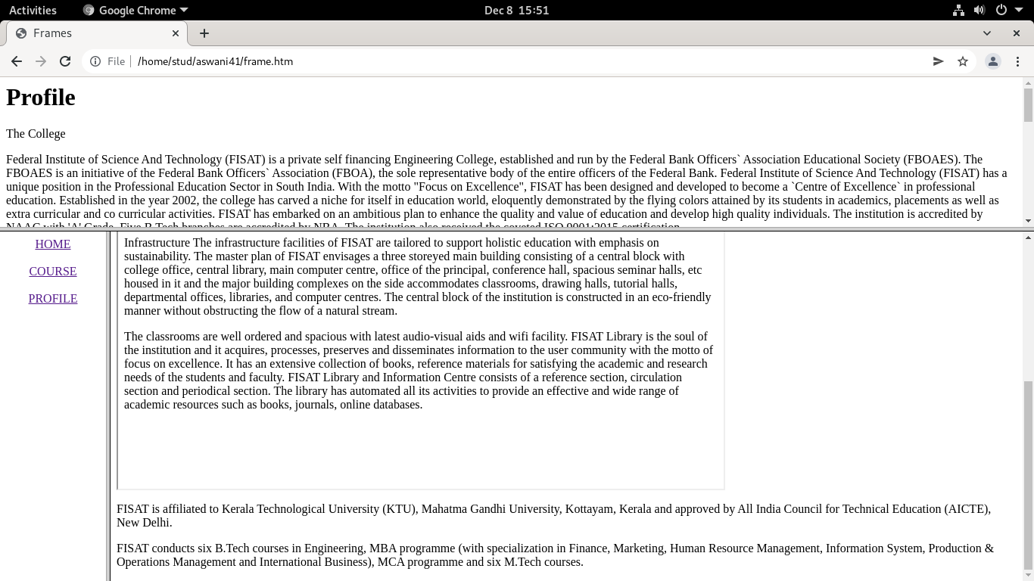

**EXPERIMENT NO:5**

**AIM:**

Analyze CSS by applying the different styles using inline, external & internal style sheets in a HTML file.

**CODE:**

**INTERNAL STYLING,INLINE STYLING**

<html>

<head>  <style>

body { background-color:lightblue; }

p{color:red;}

</style>

</head>

<body>

<h1 align="center" style="color:red;">ILLIkKAL KALLU</h1>

<p>Illikkal Kallu is a monolith located on top of the Illickal Malaa in the Kottayam district of Kerala, India.The distance from kottayam railway station to illikal kallu is 57km. Situated at around 3400 feet above sea level, Illickal Kallu is a major tourist attraction in Moonnilavu and Thalanadu village of Meenachil taluk. Only one half of the original rock remains, as the other half of the rock has fallen off. The nearest town is Teekoy. Numerous mountain streams originate from this peak and flow down to form the Meenachil River. Tourists must trek <1 km to reach the summit of the peak.

Illikkal Mala comprises three hills, each rising up to 3,400 ft above sea level. Each of the hills has a peculiar shape. One of them resembles a mushroom, which is why it is known as Kuda Kallu (umbrella-shaped rock). The second hill has a small hunch on the sides and is therefore referred to as Koonu Kallu (hunch back rock). There is a 1⁄2-foot-wide bridge called Narakapalam (bridge to hell) connecting these two hills. The beauty and the landscape of illikkal kallu is similar to that of the pillar rocks in Kodaikanal. It is said that the mythical medicinal herb Neela Koduveli grows here. This mythical blue flower is also believed to possess supernatural powers, which could increase wealth and ensure a rich harvest.[1]

From the hilltops, the Arabian Sea can be seen on the far horizon as a thin blue stroke. The view of the sunset from above the peak in the evening of a full moon day can be sensational: the moon can be seen rising up like another sun, as the orange sun goes down. <p>

</body>

</html>

**OUTPUT:**

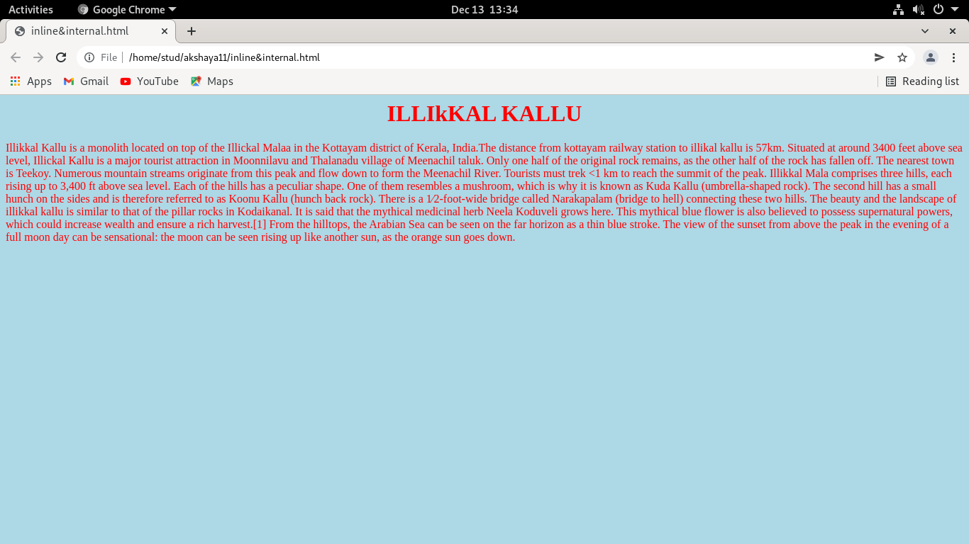

**EXTERNAL STYLING**

<html>

<head>

 <link rel="stylesheet" href="mystyle.css">

</head>

<body>

<h1 align="center">ILLIkKAL KALLU</h1>

<p>Illikkal Kallu is a monolith located on top of the Illickal Malaa in the Kottayam district of Kerala, India.The distance from kottayam railway station to illikal kallu is 57km. Situated at around 3400 feet above sea level, Illickal Kallu is a major tourist attraction in Moonnilavu and Thalanadu village of Meenachil taluk. Only one half of the original rock remains, as the other half of the rock has fallen off. The nearest town is Teekoy. Numerous mountain streams originate from this peak and flow down to form the Meenachil River. Tourists must trek <1 km to reach the summit of the peak.

Illikkal Mala comprises three hills, each rising up to 3,400 ft above sea level. Each of the hills has a peculiar shape. One of them resembles a mushroom, which is why it is known as Kuda Kallu (umbrella-shaped rock). The second hill has a small hunch on the sides and is therefore referred to as Koonu Kallu (hunch back rock). There is a 1⁄2-foot-wide bridge called Narakapalam (bridge to hell) connecting these two hills. The beauty and the landscape of illikkal kallu is similar to that of the pillar rocks in Kodaikanal. It is said that the mythical medicinal herb Neela Koduveli grows here. This mythical blue flower is also believed to possess supernatural powers, which could increase wealth and ensure a rich harvest.[1]

From the hilltops, the Arabian Sea can be seen on the far horizon as a thin blue stroke. The view of the sunset from above the peak in the evening of a full moon day can be sensational: the moon can be seen rising up like another sun, as the orange sun goes down. <p>

</body>

</html>

**mystyle.css**

body {

  background-color: lightblue;

}

h1 {

  color: navy;

  margin-left: 20px;

}

**OUTPUT:**

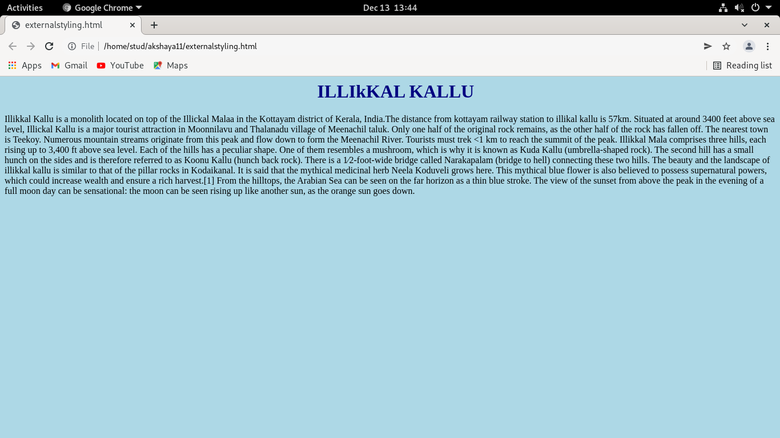

**EXPERIMENT NO:6**

**AIM:**

Create a HTML registration form and to validate the form using JavaScript code.

**CODE:**

<html>

<head>

<title>Data Validation</title>

<body>

<p>Enter a number and click OK</p>

<input id="id1" type=number min="100" max="300" required>

<button onclick="myFunction()">OK</button>

<p>If the number is less than 100 or greater than 300, an error message will be

displayed.</p>

<p id="demo"></p>

<script>

function myFunction() {

var inpObj = document.getElementById("id1");

if (inpObj.checkValidity() == false) {

document.getElementById("demo").innerHTML = inpObj.validationMessage;

} else {

document.getElementById("demo").innerHTML = "Input OK";

}

}

</script>

</body>

</html>

**OUTPUT:**

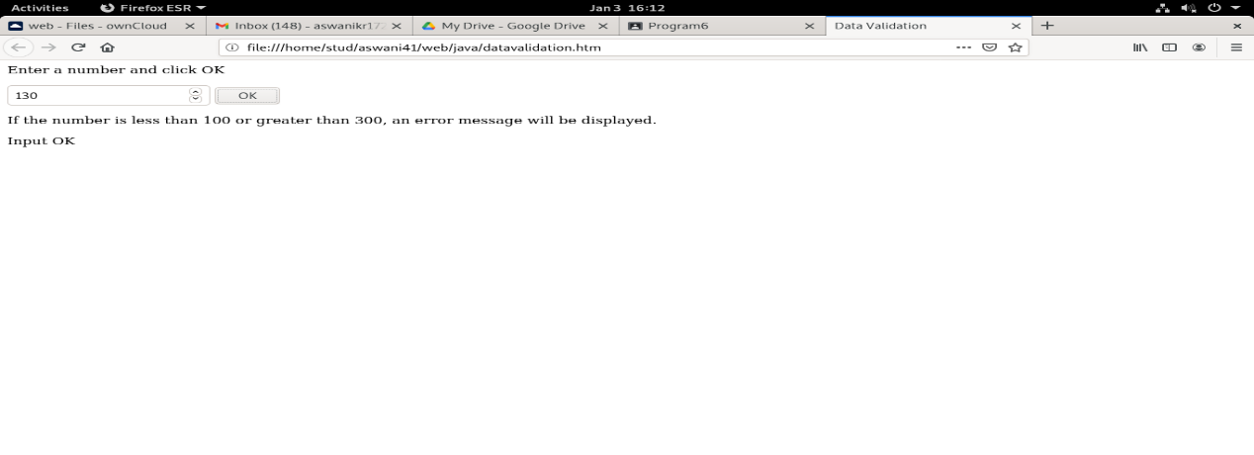

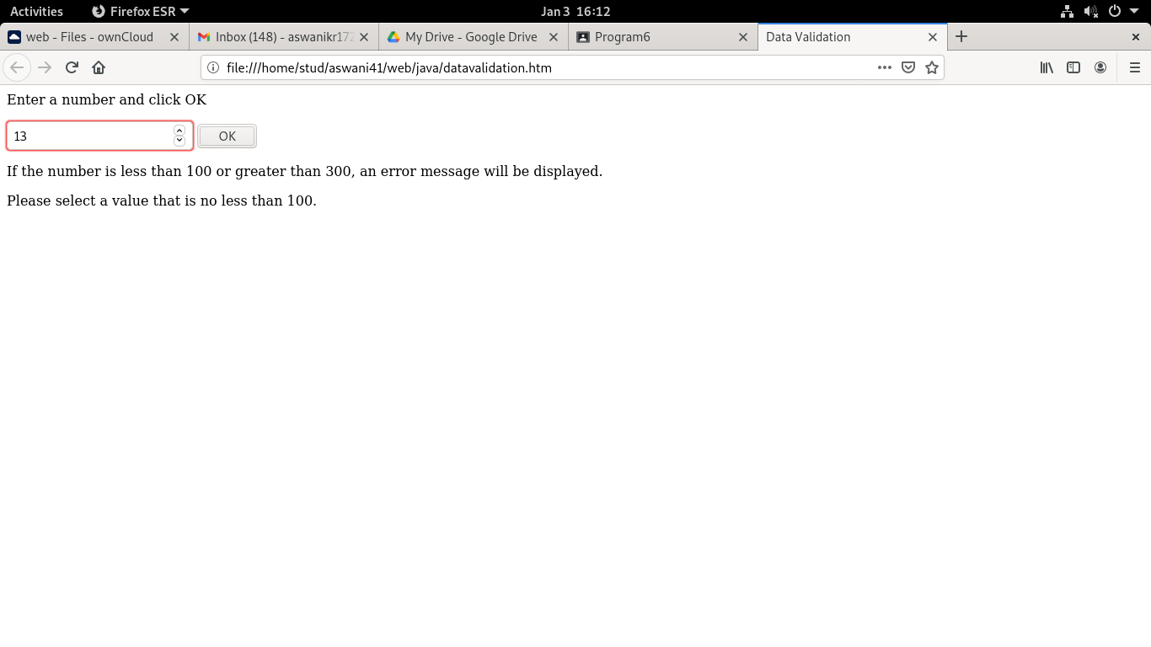

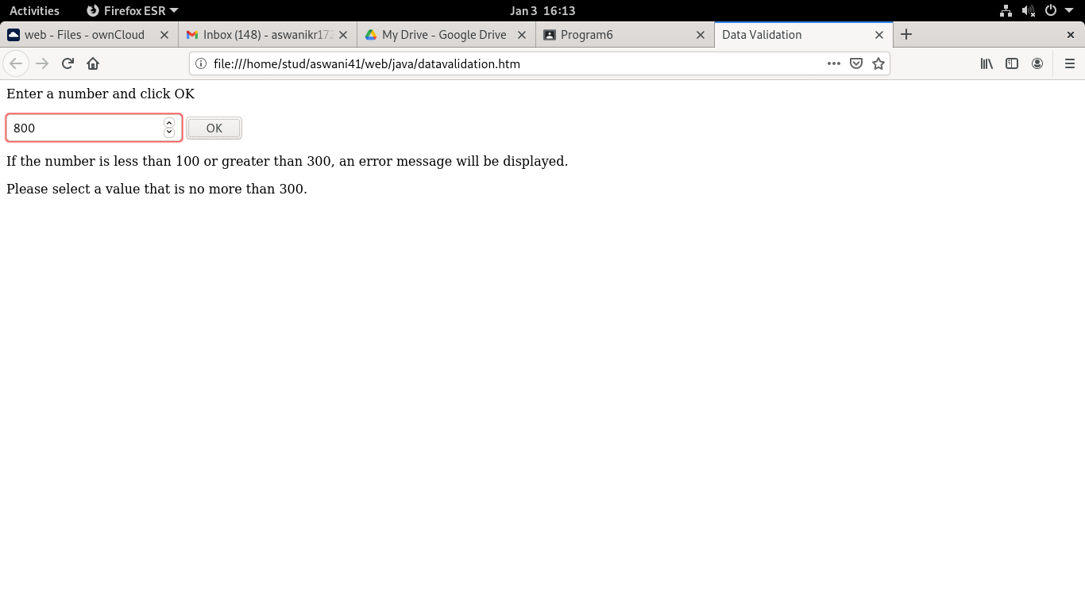

**EXPERIMENT NO: 7**

**AIM:**

Create a HTML page to explain the use of various predefined functions in a string and math objects in JavaScript.  
  
( String Functions-Length,slice,substring,substr,replace,toUppercase,toLowercase,concat,trim,charAt,convert string to array,indexof, search,includes)(Math Functions- round,ceil,floor,trunc,sign, pow,sqrt,abs,sin,cos,min,max,random,log)

**CODE:**

<html>

<body>

<h1>String and Math Function</h1>

<h3><u>String Functions</u></h3>

<p>The length of the string:</p>

<p id="demo"></p>

<script>

let text = "webprogramming";

document.getElementById("demo").innerHTML = text.length;

</script>

<h2>Slice</h2>

<p id="demo1"></p>

<script>

let str = "dog,cat,cow";

document.getElementById("demo1").innerHTML = str.slice(4,7);

</script>

<h2>Substring</h2>

<p id="demo2"></p>

<script>

let text1 = "dog,cat,cow";

document.getElementById("demo2").innerHTML = text1.substring(4,7);

</script>

<h2>Substr</h2>

<p id="demo3"></p>

<script>

let text2 = "Apple, Banana, Kiwi";

document.getElementById("demo3").innerHTML = text2.substr(7,6);

</script>

<h2>Replace</h2>

<button onclick="myFunction()">Try it</button>

<p id="demo4">Welcome to Microsoft</p>

<script>

function myFunction() {

  let text3 = document.getElementById("demo4").innerHTML;

  document.getElementById("demo4").innerHTML =

  text3.replace("Microsoft","W3Schools");

}

</script>

<h2>toupper</h2>

<button onclick="myFunction1()">Try it</button>

<p id="demo5">welcome</p>

<script>

function myFunction1() {

  let text = document.getElementById("demo5").innerHTML;

  document.getElementById("demo5").innerHTML =

  text.toUpperCase();

}

</script>

<h2>tolower</h2>

<button onclick="myFunction2()">Try it</button>

<p id="demo6">WELCOME</p>

<script>

function myFunction2() {

  let text = document.getElementById("demo6").innerHTML;

  document.getElementById("demo6").innerHTML =

  text.toLowerCase();

}

</script>

<h2>concat</h2>

<p id="demo7"></p>

<script>

let texta = "Hai";

let textb = "Welcome";

let textc = texta.concat(" ",textb);

document.getElementById("demo7").innerHTML = textc;

</script>

<h2>trim</h2>

<p id="demo8"></p>

<script>

let textx = "     Welcome to web     ";

let texty = textx.trim();

document.getElementById("demo8").innerHTML =

"Length textx=" + textx.length + "<br>Length2 texty=" + texty.length;

</script>

<h2>charat</h2>

<p id="demo9"></p>

<script>

var textm = "WELCOME";

document.getElementById("demo9").innerHTML = textm.charAt(1);

</script>

<h2>String to array</h2>

<p id="demo10"></p>

<script>

let textn = "a,b,c,d,e,f";

const myArray = textn.split(",");

document.getElementById("demo10").innerHTML = myArray[0];

</script>

<h2>indexof</h2>

<p id="demo11"></p>

<script>

let str1 = "Please locate where 'locate' occurs!";

document.getElementById("demo11").innerHTML = str1.indexOf("locate");

</script>

<h2>search</h2>

<p id="demo12"></p>

<script>

let str2 = "Please locate where 'locate' occurs!";

document.getElementById("demo12").innerHTML = str2.search("locate");

</script>

<h2>include</h2>

<p id="demo13"></p>

<p>The includes() method is not supported in Internet Explorer.</p>

<script>

let textf= "Hello world, welcome to the universe.";

document.getElementById("demo13").innerHTML = textf.includes("world");

</script>

<h3><u>math functions</u></h3>

<h2>round</h2>

<p>Returns the value of x rounded to its nearest integer:</p>

<p id="demo14"></p>

<script>

document.getElementById("demo14").innerHTML = Math.round(6.5);

</script>

<h2>ceil</h2>

<p>nearest integer:</p>

<p id="demo15"></p>

<script>

document.getElementById("demo15").innerHTML = Math.ceil(5.4);

</script>

<h2>floor</h2>

<p>nearest integer:</p>

<p id="demo16"></p>

<script>

document.getElementById("demo16").innerHTML = Math.floor(7.7);

</script>

<h2>trunc</h2>

<p>returns the integer part of x:</p>

<p id="demo17"></p>

<script>

document.getElementById("demo17").innerHTML = Math.trunc(2.7);

</script>

<h2>sign</h2>

<p>returns if x is negative, null or positive:</p>

<p id="demo18"></p>

<script>

document.getElementById("demo18").innerHTML = Math.sign(4);

</script>

<h2>pow</h2>

<p>returns the value of x to the power of y:</p>

<p id="demo19"></p>

<script>

document.getElementById("demo19").innerHTML = Math.pow(4,2);

</script>

<h2>sqrt</h2>

<p>returns the square root of x:</p>

<p id="demo20"></p>

<script>

document.getElementById("demo20").innerHTML = Math.sqrt(121);

</script>

<h2>absolute</h2>

<p>returns the absolute (positive) value of x:</p>

<p id="demo21"></p>

<script>

document.getElementById("demo21").innerHTML = Math.abs(-6.4);

</script>

<h2>sin</h2>

<p id="demo22"></p>

<script>

document.getElementById("demo22").innerHTML =

"The sine value of 90 degrees is " + Math.sin(90 * Math.PI / 180);

</script>

<h2>cos</h2>

<p id="demo23"></p>

<script>

document.getElementById("demo23").innerHTML =

"The cosine value of 0 degrees is " + Math.cos(0 * Math.PI / 180);

</script>

<h2>min</h2>

<p id="demo24"></p>

<script>

document.getElementById("demo24").innerHTML =

Math.min(0, 15, 30, 20, -10, -20);

</script>

<h2>max</h2>

<p id="demo25"></p>

<script>

document.getElementById("demo25").innerHTML =

Math.max(0, 15, 30, 20, -10, -20);

</script>

<h2>random</h2>

<p id="demo26"></p>

<script>

document.getElementById("demo26").innerHTML = Math.random();

</script>

<h2>log</h2>

<p id="demo27"></p>

<script>

document.getElementById("demo27").innerHTML = Math.log(1);

</script

</body>

</html>

**OUTPUT:**

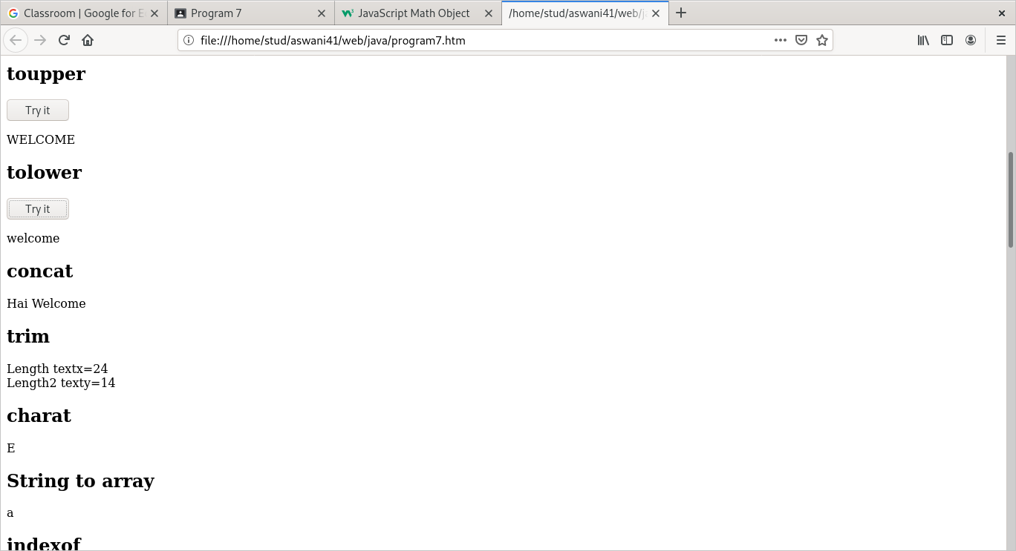

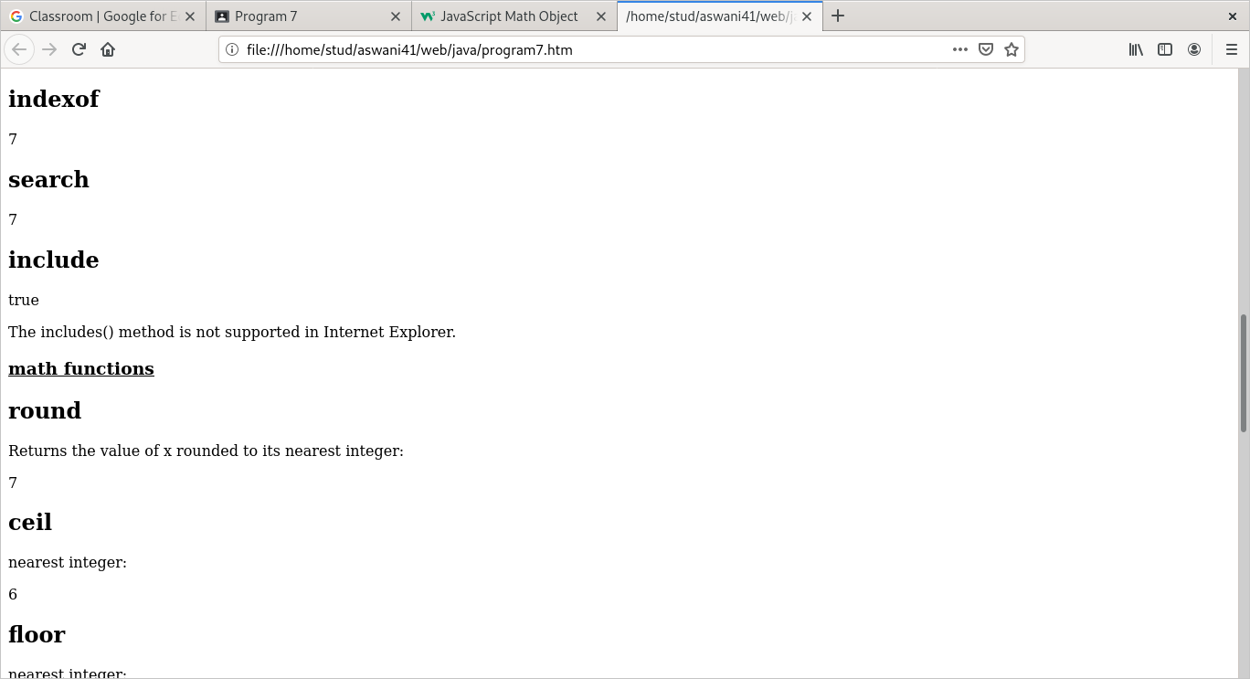

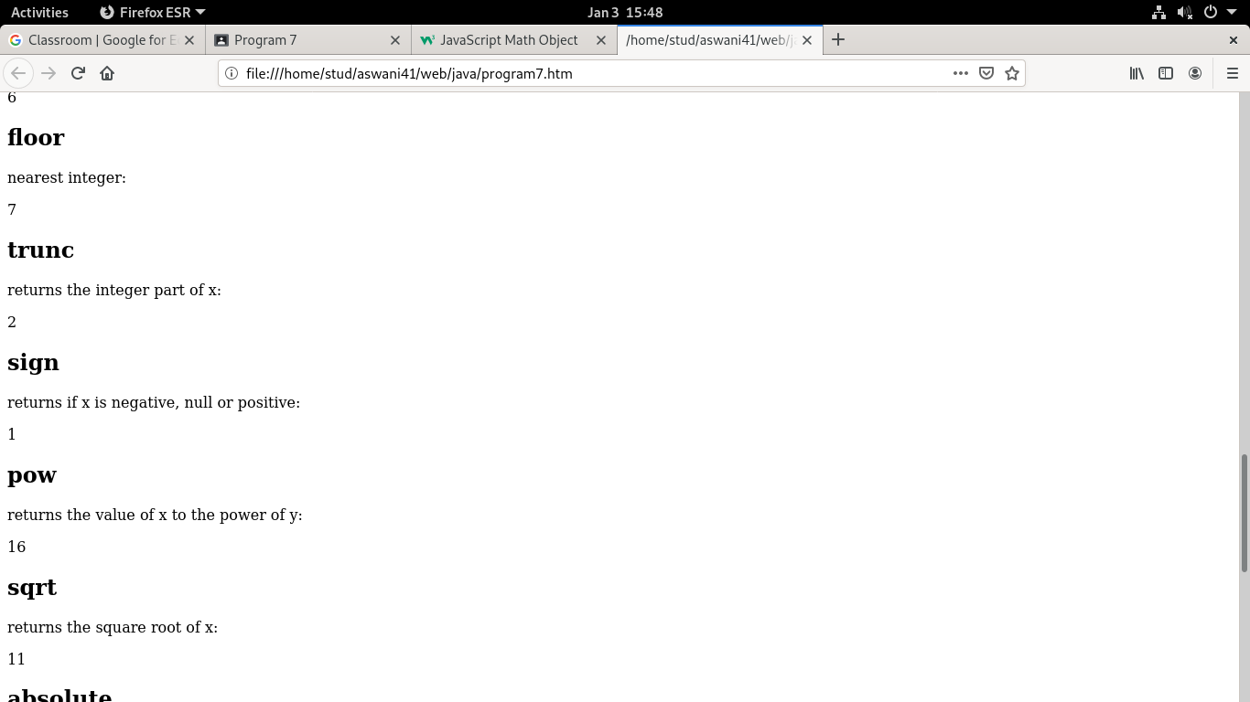

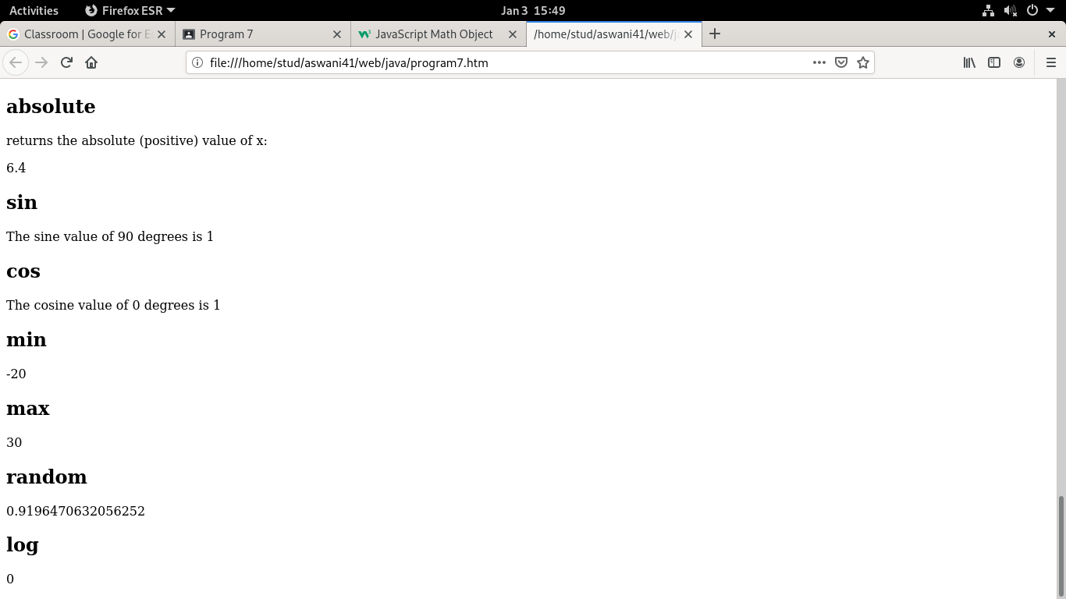

**EXPERIMENT NO:8**

**AIM:**

Create a HTML page to change the background color for every click of a button  
using JavaScript Event Handling.

**CODE:**

<html>

<head>

<title>background color change</title>

</head>

<body style = "text-align:center;">

<h1 style = "color:red;" >

Welcome

</h1>

<button type="button" id="color-button" onclick="changeBg()">Click Here

</button>

<br>

<script>

document.writeln( "Click on button to change the background color");

const pageBody = document.querySelector("body");

function changeBg()

{

let color = '#'+(Math.random()*0xFFFFFF<<0).toString(16);

pageBody.style.background = color;

}

</script>

</body>

</html>

**OUTPUT:**

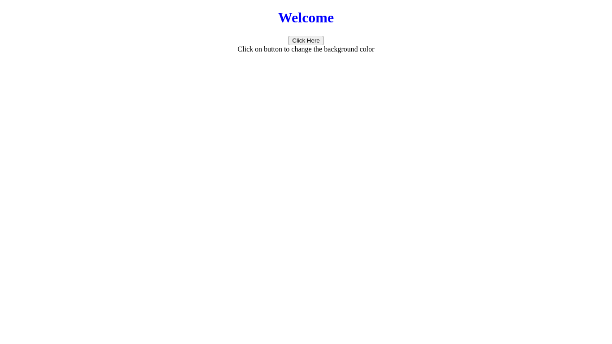



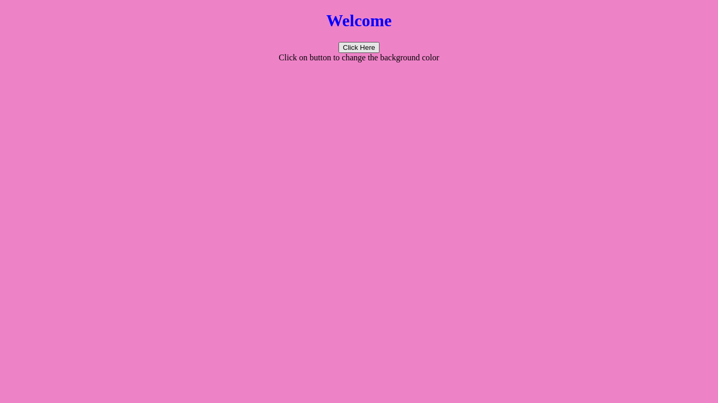

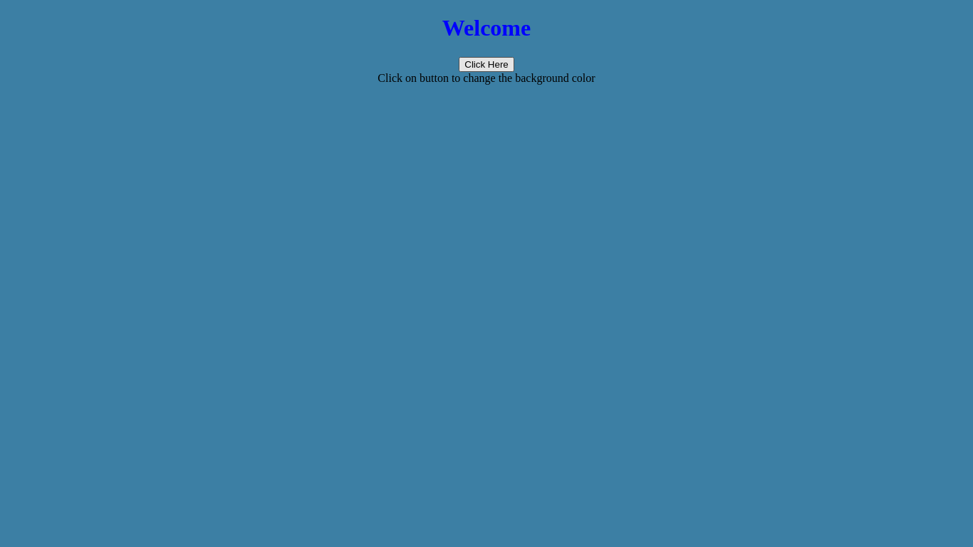

**EXPERIMENT NO:9**

**AIM:**

Generate the calendar using JavaScript code by getting the year and month from the user.

**CODE:**

<head>

<title>Calendar</title>

<style>

table {

border-collapse: collapse;

}

td, th {

border: 1px solid black;

padding: 3px;

text-align: center;

}

th {

font-weight: bold;

background-color: #E6E6E6;

}

</style>

</head>

<body>

<b><u>CALENDAR</u></b><br>

Enter The year : <input type="number" name="cal" id="cal" /><br><br>

Enter The Month: <input type="number" name="month" id="month" />

<br><br>

<div id="calendar"></div>

<button onclick=>

<script>

var year = document.getElementById("cal").value;

var month = document.getElementById("month").value;

function getDay(date) {

let day = date.getDay();

if (day == 0) day = 7;

return day - 1;

}

function createCalendar(elem, year, month) {

let mon = month - 1;

let d = new Date(year, mon);

let table =

'<table><tr><th>MON</th><th>TUE</th><th>WED</th><th>THU</th><th>FRI</th><th>SAT</th><th>SUN</th></tr><tr>';

for (let i = 0; i < getDay(d); i++) {

table += '<td>*</td>';

}

while (d.getMonth() == mon) {

table += '<td>' + d.getDate() + '</td>';

if (getDay(d) % 7 == 6) {

table += '</tr><tr>';

}

d.setDate(d.getDate() + 1);

}

if (getDay(d) != 0) {

for (let i = getDay(d); i < 7; i++) {

table += '<td>*</td>';

}

}

table += '</tr></table>';

elem.innerHTML = table;

}

createCalendar(calendar, year, month);

</script>

</body>

</html>

**OUTPUT:**

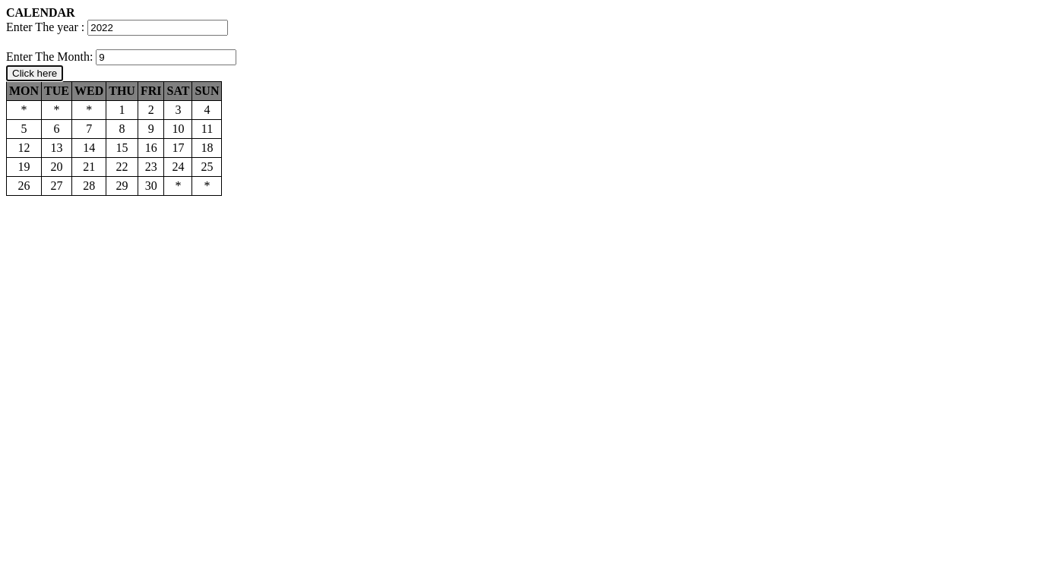

**EXPERIMENT NO:10**

**AIM:**

Compose Electricity bill from user input based on a given tariff using PHP.

**CODE:**

bill.html

<html>

<head>

<title>electricity</title>

</head>

<body>

<form align="center" action="submit1.php" method="post">

Consumer_name:<input type="text" name="a"></input>

Consumer_id:<input type="number" name="c"></input>

Units_consumed:<input type="number" name="u"></input>

<input type="submit" value="submit">

</form>

</body>

</html>

submit1.php:

<?php

$s=$_POST['u'];

$h=$_POST['a'];

$y=1.5;

$z=$s*$y;

echo "$h is wanted to pay amount $z";

?>

**OUTPUT:**

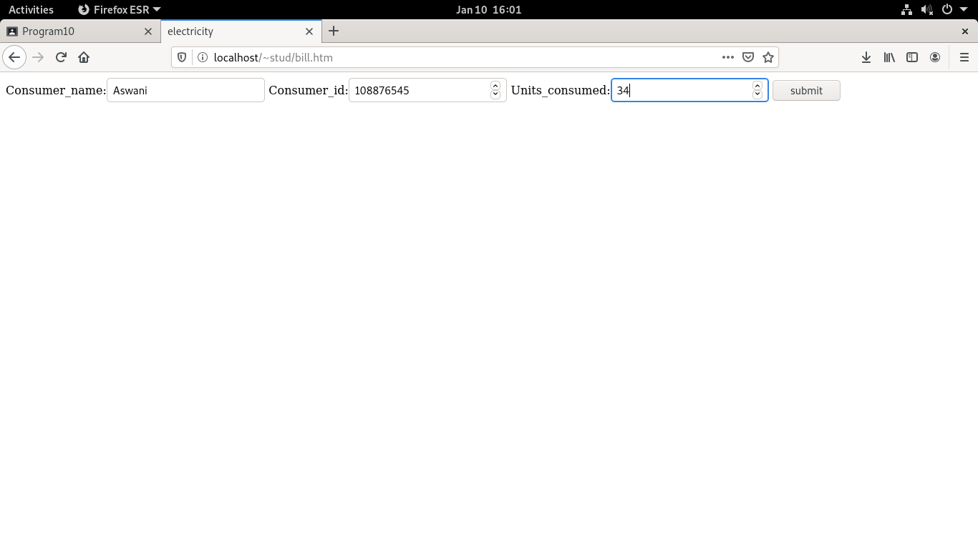

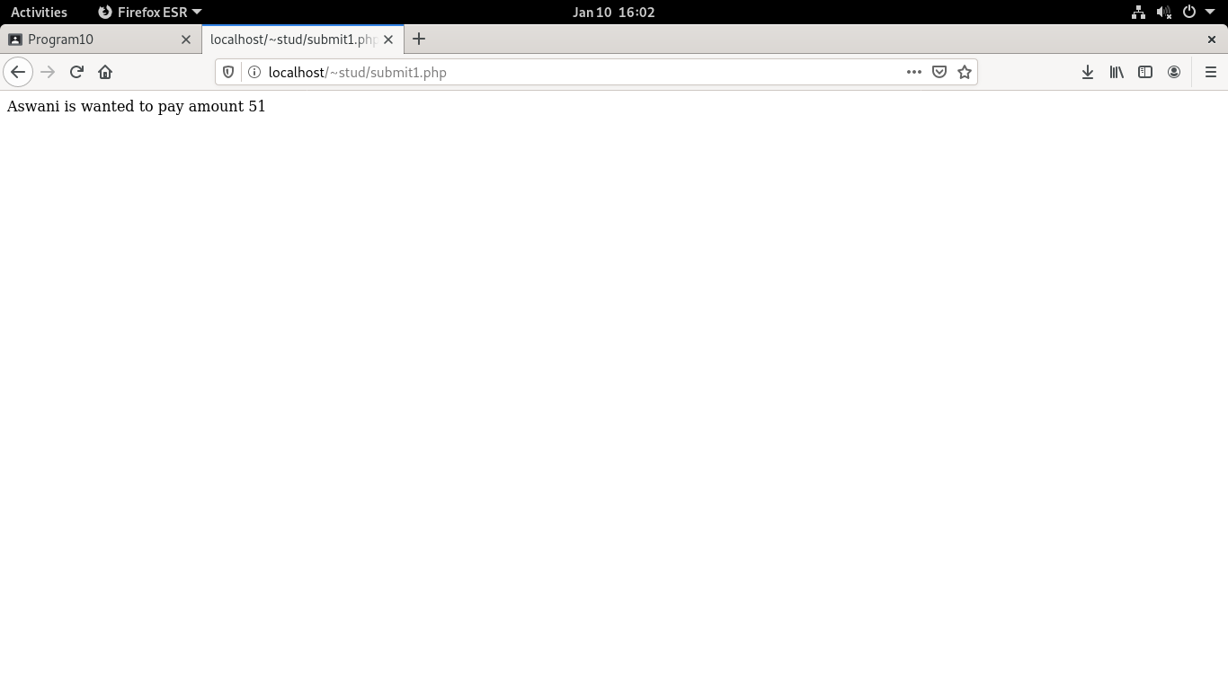

**EXPERIMENT NO:11**

**AIM:**

Build a PHP code to store name of students in an array and display it using print_r function. Sort and Display the same using asort & arsort functions.

**CODE:**

<?php $arr=array("Anu","Aparna","Asna","Ardra");

echo 'Arayy $arr :';

echo "&nbsp;&nbsp;&nbsp;&nbsp;&nbsp;";

print_r($arr);

echo "<br>";

sort($arr);

echo 'Arayy $arr after asort() :';

echo "&nbsp;&nbsp;&nbsp;&nbsp;&nbsp;";

print_r($arr);

echo "<br>";

asort($arr);

echo 'Arayy $arr after arsort() :';

echo "&nbsp;&nbsp;&nbsp;&nbsp;&nbsp;";

print_r($arr);

?>

**OUTPUT:**

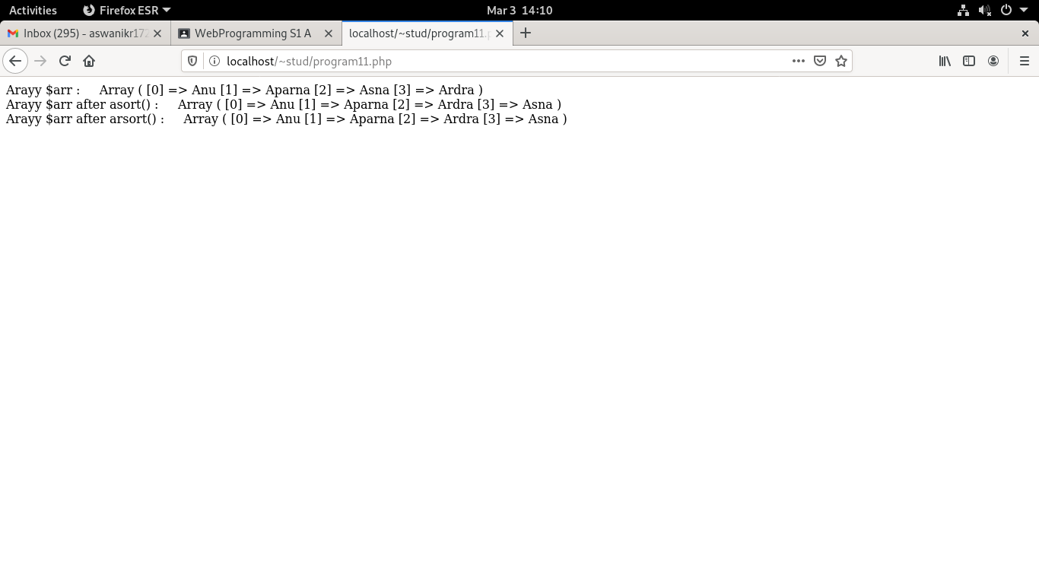

**EXPERIMENT NO:12**

**AIM:**

Build a PHP code to store name of Indian Cricket players in an array and display the same in HTML table.

**CODE:**

<html>

<body>

<?php

$Indcricketers= array("Virat Kohli", "M S Dhoni", "Rohit Sharma"); echo "Indian Cricketers: " .  $Indcricketers[0] . ", " . $Indcricketers[1] ." and" . $Indcricketers[2] . "."; echo "<h3>INDIAN  CRICKETERS</h3><table border='1'>

<tr>

<th>NO</th>

<th>NAMES</th>

</tr>

<tr>

<td>1</td>

<td>Virat Kohli</td>

</tr>

<tr>

<td>2</td>

<td>M S Dhoni</td>

</tr>

<tr>

<td>3</td>

<td>Rohit Sharma</td>

</tr>";

?>

</body>

</html>

**OUTPUT**:

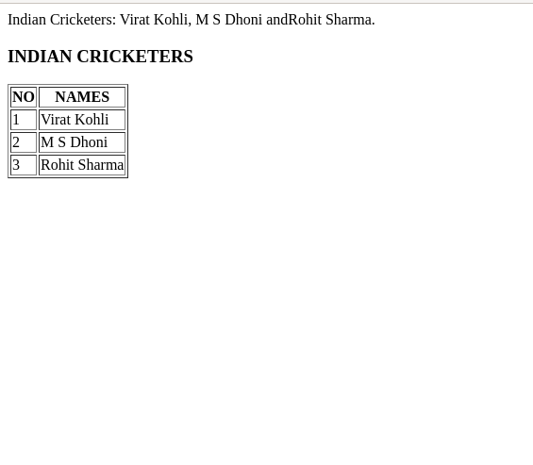

**EXPERIMENT NO:13**

**AIM:**

Using PHP and MySQL, develop a program to accept book information viz.Accession number, title, authors, edition and publisher from a web page and store the information in a database and to search for a book with the title specified by the user and to display the search results with proper headings

**CODE:**

**bookinfo.html**

<html>

<head>

<title>book</title>

</head>

<body align="center"><u>BOOK INFORMATION SYSTEM</u><br>

<a href="add_book.html">Add Book</a><br>

<a href="searchl.html">Search Book</a><br>

</body>

</html>

**add_book.html**

<html><head>

<title>add book</title></head>

<body>

<form name="frm1" action="addl.php" method="POST">

<center><b><u>Enter Book Details</u></b><br>

Access Number:<input type="text" name="num"><br><br>

Title:<input type="text" name="tit"><br><br>

Author:<input type="text" name="author"><br><br>

Edition:<input type="text" name="edi"><br><br>

Publisher:<input type="text" name="pub"><br><br>

<input type="submit" name="Submit">

<input type="reset" name=“Reset">

</form>

</body>

</html>

**searchl.html**

<html>

<head>

<title>search</title>

</head>

<body>

<form name="frm2" action="searchl.php" method="POST">

<center>

<b><u>SEARCH A BOOK</u></b><br>

Enter book title:<input type="text" name="txt"><br>

<input type="submit" name="Submit">

</center>

</form>

</body>

</html

**addl.php**

<?php

$num=$_POST['num'];

$tit=$_POST['tit'];

$author=$_POST['author'];

$edi=$_POST['edi'];

$pub=$_POST['pub'];

$con=new mysqli("localhost","fisat","fisat","fisatdb");

if($con==false)

{ echo "Failed to connect"; }

else

{ echo "connected"; }

$sql="INSERT INTO BOOK11 VALUES($num,'$tit','$author',$edi,'$pub')";

if($con->query($sql))

{

echo "<BR>";

echo 'New row added';

}

else

{

echo "ERROR:could not execute query";

}

$con->close();

?>

**searchl.php**

<?php

$title=$_POST['txt'];

$con=new mysqli("localhost","fisat","fisat","fisatdb");

if($con==false)

{

echo "Failed to connect";

}

else

{

echo "connected\n";

}

$sql="select * from BOOK11 where Title='$title'";

if($result=$con->query($sql))

{

if($result->num_rows>0)

{

while($row=$result->fetch_array())

{ echo "'\n".$row[0].":".$row[1].":".$row[2].":".$row[3].":".

   $row[4]."\n";}

$result->close();

}else

{ echo "\nCould not found the book"; }

}

else

{ echo "\nError:could not connect"; }

$con->close();

?>

**OUTPUT**

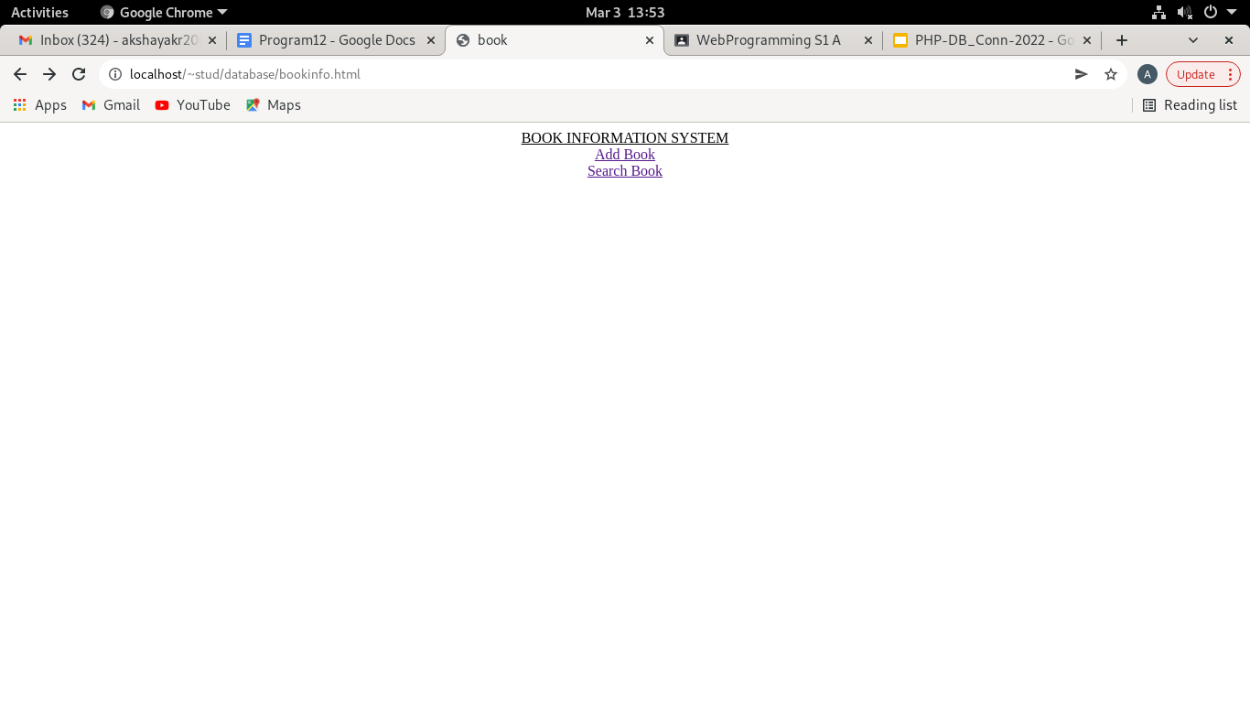

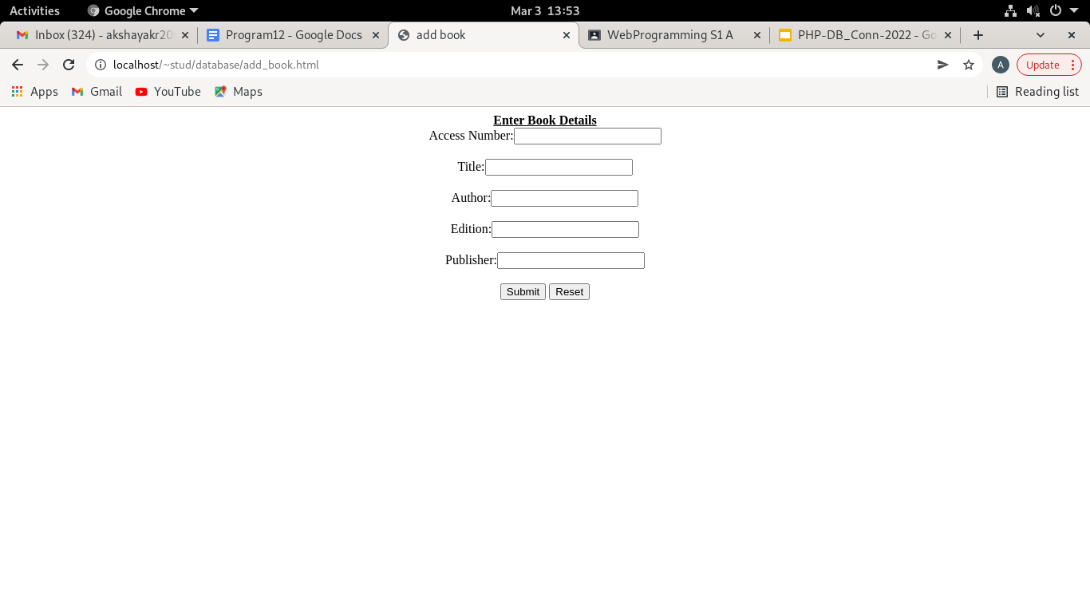

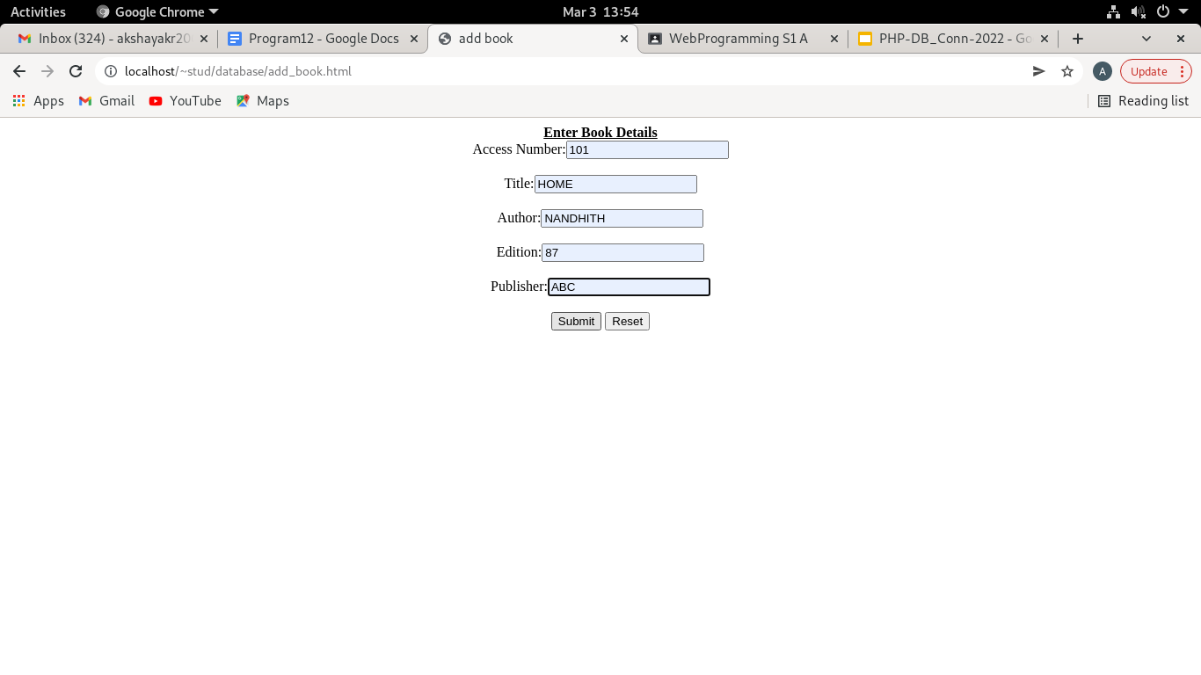

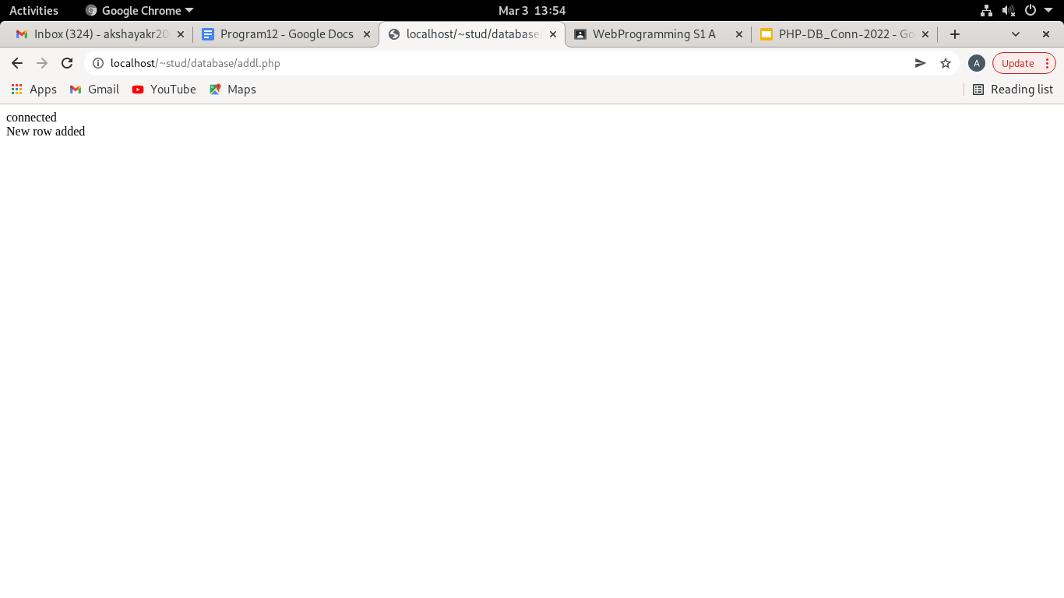

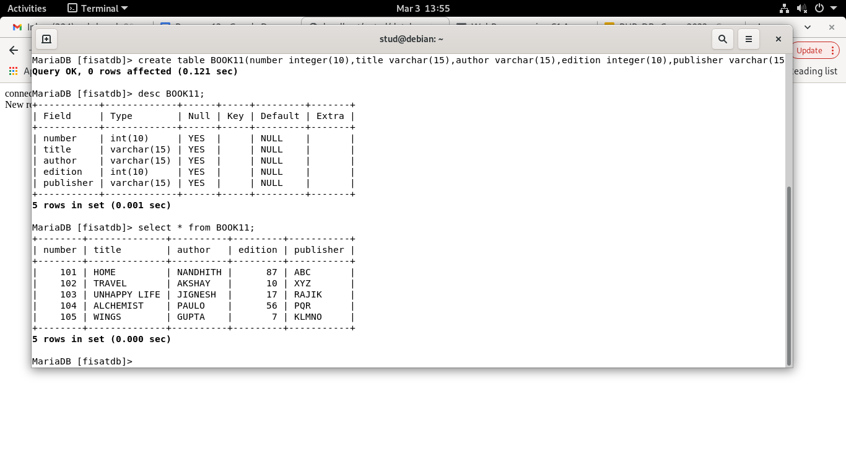

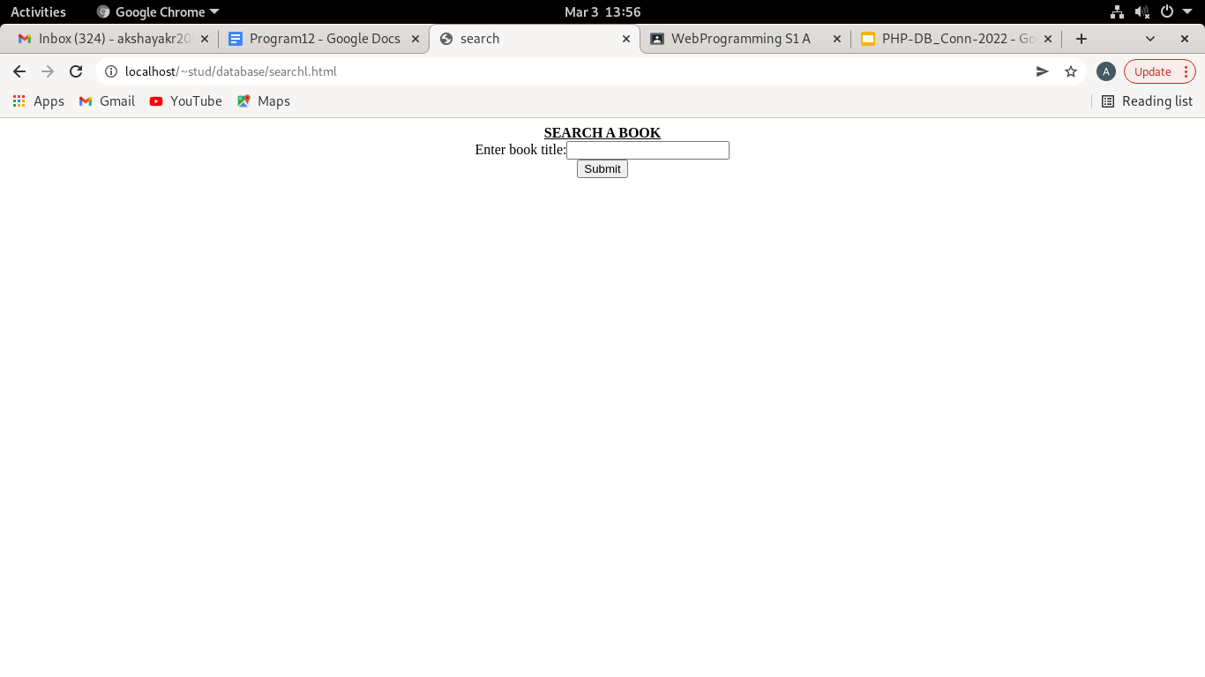

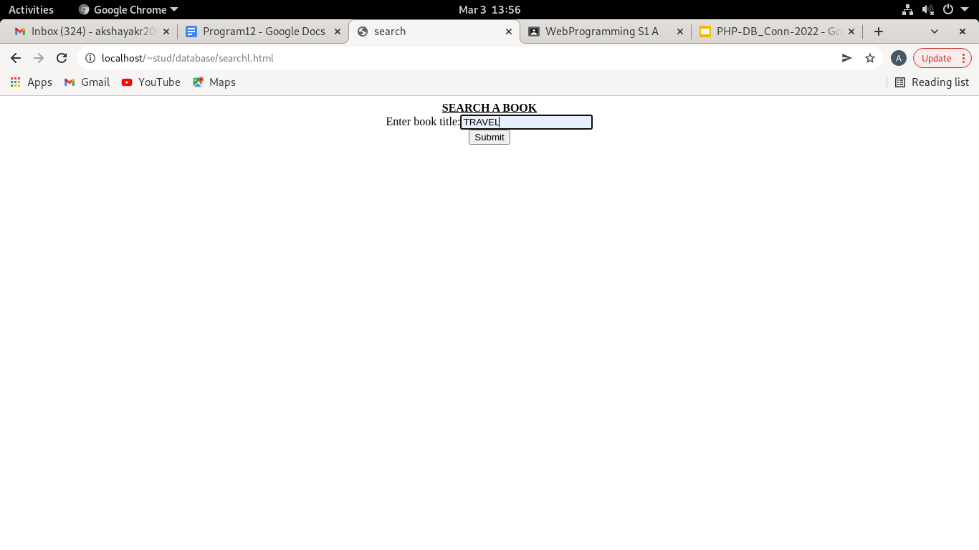

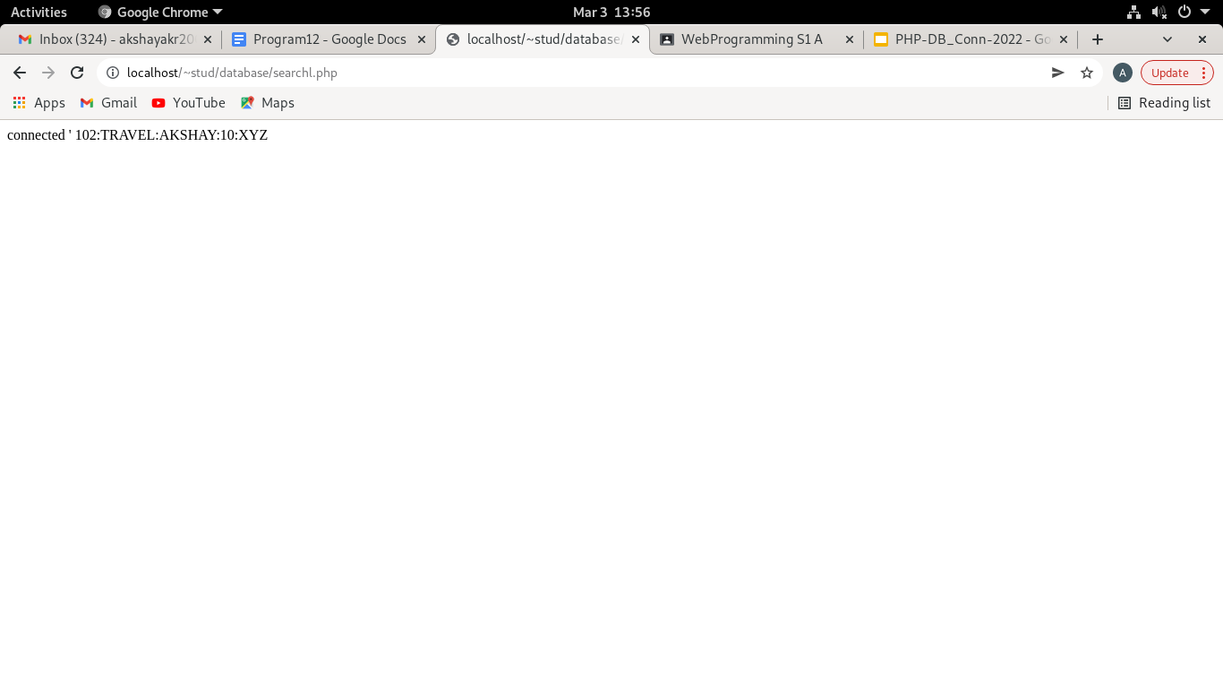

**EXPERIMENT NO:14**

**AIM:**

Using PHP and MySQL, develop a program to collect airline details and display all the airlines between a particular source and destination.

**CODE:**

**airlineinfo.html**

<html>

<head>

<title>book</title>

</head>

<body align="center"><u>AIRLINE INFORMATION SYSTEM</u><br>

<a href="addairline.html">Add airline details</a><br>

<a href="airlinel.html">Search airline</a><br>

</body>

</html>

**addairline.html**

<html><head>

<title>add airline</title></head>

<body>

<form name="frm1" action="addl.php" method="POST">

<center><b><u>Enter Airline Details</u></b><br>

 Airline Number:<input type="text" name="num"><br><br>

Airline name:<input type="text" name="name"><br><br>

Source:<input type="text" name="source"><br><br>

Destination:<input type="text" name="dest"><br><br>

<input type="submit" name="Submit">

<input type="reset" name=“Reset">

</form>

</body>

</html>

**airlinel.html**

<html>

<head>

<title>search</title>

</head>

<body>

<form name="frm2" action="searchl.php" method="POST">

<center>

<b><u>SEARCH </u></b><br>

Source:<input type="text" name="source"><br><br>

Destination:<input type="text" name="dest"><br>

<input type="submit" name="Submit">

</center>

</form>

</body>

</html>

**addl.php**

<?php

$num=$_POST['num'];

$name=$_POST['name'];

$source=$_POST['source'];

$dest=$_POST['dest'];

$con=new mysqli("localhost","fisat","fisat","fisatdb");

if($con==false)

{ echo "Failed to connect"; }

else

{ echo "connected"; }

$sql="INSERT INTO airline111 VALUES($num,'$name','$source','$dest')";

if($con->query($sql))

{

echo "<BR>";

echo 'New row added';

}

else

{

echo "ERROR:could not execute query";

}

$con->close();

?>

**searchl.php**

<?php

$source=$_POST['source'];

$dest=$_POST['dest'];

$con=new mysqli("localhost","fisat","fisat","fisatdb");

if($con==false)

{

echo "Failed to connect";

}

else

{

echo "connected\n";

}

$sql="select * from airline111 where source='$source' and destination='$dest'";

if($result=$con->query($sql))

{

if($result->num_rows>0)

{

while($row=$result->fetch_array())

{ echo "'\n".$row[0].":".$row[1].":".$row[2].":".$row[3]."\n";}

$result->close();

}else

{ echo "\nCould not found the airline"; }

}

else

{ echo "\nError:could not connect"; }

$con->close();

?>

**OUTPUT**



